*SuperStore Sales Project*

# Project Objective:

* To contribute to the success of a business by utilizing data analysis techniques, specifically focusing on time series analysis, to provide valuable insights and accurate sales forecasting.

# Description:

* The Objective can be broken down into the following detailed components:

1. Dashboard Creation: Identify the KPIs, design an intuitive and usually appealing dashboard, add interactive visualization and filtering capabilities to allow users to explore the data at various levels of granularity.
2. Data Analysis: To provide valuable insights to business entities regarding the effectiveness of their sales Strategy Through visualization and charts.
3. Sales Forecasting: Leverage historic data and apply time series analysis to generate sales forecasts for the next 15 days.
4. Actionable Insights and Recommendation: End goals is to share valuable insights and actionable information that can drive strategic decision making and support the supermarkets goals for growth, efficiency, customer statisfaction.

## **Dashboard Creation:**

The primary objective of the dashboard creation is to identify Key Performance Indicators (KPIs), design an intuitive and visually appealing dashboard, and add interactive visualization and filtering capabilities to allow users to explore the data at various levels of granularity.

### **KPIs Identified:**

* Total Sales
* Total Orders
* Total Profit
* Average Ship Days
* Sales by Region
* Sales by Segment
* Sales by Payment Mode
* Sales by Category and Sub-Category
* Sales by Ship Mode
* Sales and Sum of Profit by State

### **Dashboard Features:**

* **Sales by Region**: Visualized using a pie chart, providing insights into the distribution of sales across different regions.
* **Sales by Segment**: Separate pie charts to show sales distribution by segment (Home Office, Corporate, Consumer).
* **Sales by Payment Mode**: Highlighting the most used payment methods (Cards, Online, COD).
* **Sales and Profit Trends**: Line charts showing monthly sales and profit trends for 2019 and 2020.
* **Sales by Category and Sub-Category**: Bar charts for in-depth analysis of product categories and sub-categories.
* **Sales by Ship Mode**: Indicating preferred shipping methods and their sales contribution.
* **Sales and Sum of Profit by State**: Geographical visualization of sales and profit distribution across the US.

## **2. Data Analysis:**

The data analysis component focuses on providing valuable insights to business entities regarding the effectiveness of their sales strategy through visualization and charts.

### **Key Insights:**

* **Overall Sales and Performance**:
  + Total Sales: $1.6M
  + Total Orders: 22K
  + Total Profit: $175K
  + Average Ship Days: 4
* **Sales by Region**:
  + West leads with 33.37% of total sales.
  + East follows with 28.75%.
  + Central and South regions have 21.78% and 16.1% respectively.
* **Sales by Segment**:
  + Consumer segment is the highest contributor with 48.09%.
  + Corporate segment accounts for 32.55%.
  + Home Office segment contributes 19.35%.
* **Sales by Payment Mode**:
  + Online transactions are the highest (35.38%).
  + Cash on Delivery (COD) accounts for 42.62%.
  + Card payments constitute 21.99%.
* **Sales by Category and Sub-Category**:
  + Office Supplies lead with $0.64M.
  + Phones are the top sub-category with $0.20M.
* **Sales by Ship Mode**:
  + Standard Class is the most preferred shipping mode ($0.50M in sales).

## **3. Sales Forecasting:**

Leveraging historic data and applying time series analysis to generate sales forecasts for the next 15 days.

### **Forecast Insights:**

* The sales forecasting graph from January 2019 to January 2021 shows periodic peaks and troughs, indicating cyclical sales patterns.
* Recent sales patterns indicate fluctuating sales with an upward trend towards the end of December 2020.
* The forecast for January 2021 predicts a continuation of this upward trend, suggesting increased sales activity.

### **Top Performing States:**

* **California**: $0.34M
* **New York**: $0.19M
* **Texas**: $0.12M
* Other notable states include Washington ($0.09M), Pennsylvania ($0.08M), and Ohio ($0.07M).

## **4. Actionable Insights and Recommendations:**

The end goal is to share valuable insights and actionable information that can drive strategic decision-making and support the supermarket's goals for growth, efficiency, and customer satisfaction.

### **Recommendations:**

1. **Focus on High-Performing Regions**:
   * Invest more in marketing and inventory for the West and East regions, which have the highest sales.
2. **Enhance Consumer Segment**:
   * As the Consumer segment contributes the most to sales, targeted promotions and personalized marketing strategies should be employed to boost sales further.
3. **Optimize Payment Methods**:
   * Encourage the use of online transactions through promotions and discounts, given its high usage rate.
4. **Seasonal Promotions**:
   * Capitalize on the identified sales peaks by planning promotions and stock increases during these periods.
5. **Expand Top Categories**:
   * Focus on expanding the Office Supplies category and top sub-categories like Phones, which show significant sales.
6. **Improve Shipping Options**:
   * Given the preference for Standard Class shipping, ensure its efficiency and consider offering similar incentives for other shipping modes to balance the load.

# Dashboard 1 -

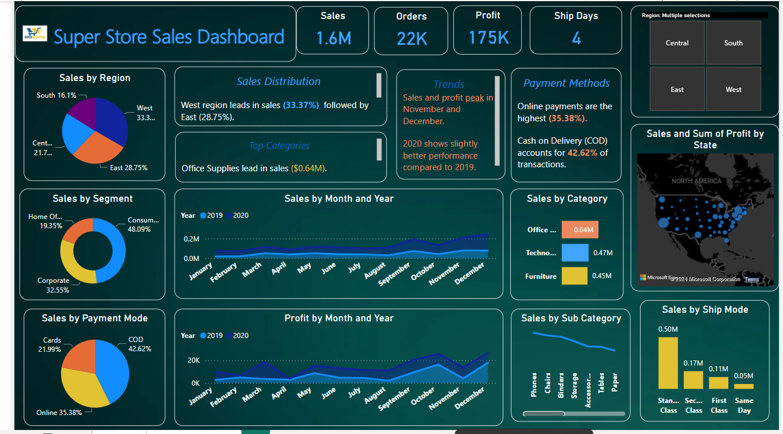

Insights:

**Sales Distribution:**

* The West region leads in sales (33.37%), followed by East (28.75%).
* Consumer segment contributes the most to sales (48.09%).

**Payment Methods:**

* Online payments are the highest (35.38%).
* Cash on Delivery (COD) accounts for 42.62% of transactions.

**Top Categories:**

* Office Supplies lead in sales ($0.64M).
* Phones are the top sub-category ($0.20M).

**Shipping Preferences:**

* Standard Class is the most used shipping mode ($0.50M in sales).

**Trends:**

* Sales and profit peak in November and December.
* 2020 shows slightly better performance compared to 2019.

# Dashboard 2 -

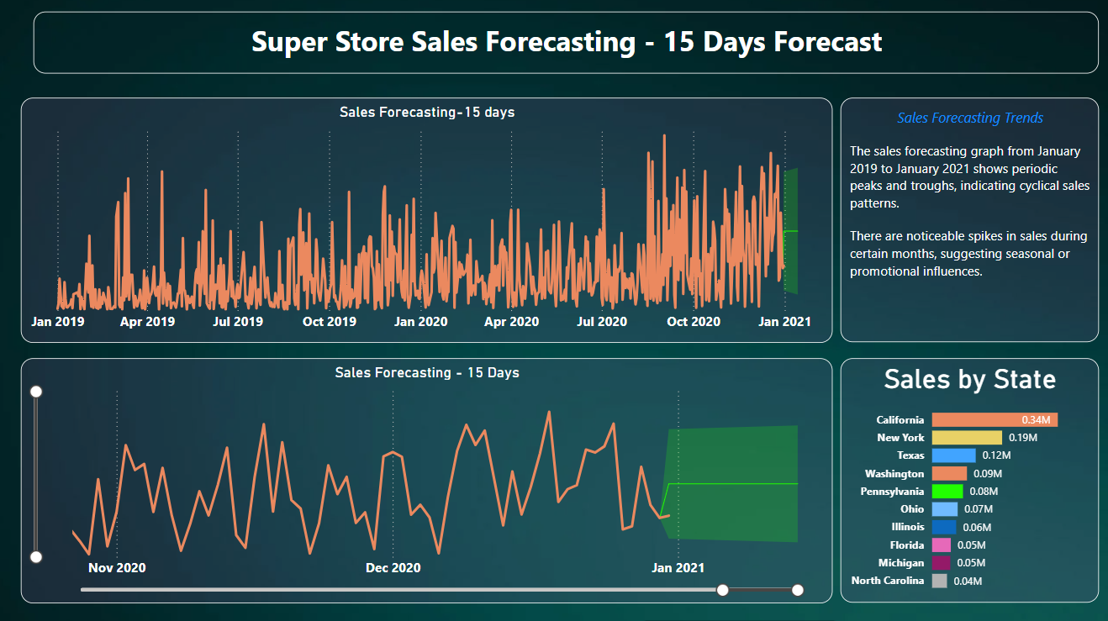

Insights:

1. **Sales Forecasting Trends:**
   * The sales forecasting graph from January 2019 to January 2021 shows periodic peaks and troughs, indicating cyclical sales patterns.
   * There are noticeable spikes in sales during certain months, suggesting seasonal or promotional influences.
2. **Recent Sales Patterns:**
   * The last few months of 2020 (November to December) show fluctuating sales with a general upward trend towards the end of December.
   * The forecast for January 2021 predicts a continuation of this upward trend, suggesting increased sales activity.
3. **Top Performing States:**
   * **California** leads significantly with $0.34M in sales.
   * **New York** follows with $0.19M in sales.
   * **Texas** is the third highest with $0.12M.
   * Other notable states include Washington ($0.09M), Pennsylvania ($0.08M), and Ohio ($0.07M).
4. **Additional State Sales Insights:**
   * Illinois, Florida, Michigan, and North Carolina have relatively lower sales, ranging from $0.04M to $0.06M.
5. **Short-Term Forecast:**
   * The 15-day sales forecast indicates a potential increase in sales as shown by the green highlighted area in the forecast graph.
   * The sales forecast for early January 2021 is projected to rise, indicating a positive outlook for the beginning of the year.

These insights highlight the cyclical nature of sales, the impact of seasonal factors, and the key states contributing to overall sales. The short-term forecast suggests a favorable start to the year 2021 in terms of sales performance.

# Conclusion:

The analysis and forecasting provided by the dashboard offer a comprehensive view of the supermarket's sales performance. By implementing the actionable insights and recommendations, the supermarket can enhance its strategic decision-making process, driving growth, efficiency, and customer satisfaction.